Stephen Marhefka & Matthew Borbonus

Luis Oliveira

CS 1980

19 September 2019

Capstone Proposal for

Smartphone GPS Duty-Cycle for Saving Battery in Navigation Project

Our project is the Smartphone GPS Duty-Cycle for Saving Battery in Navigation being led by professor Dr. Daniel Mossé. Our primary goal is to develop and tweak algorithms that can be utilized by mobile navigational systems that will enable us to turn on and off the GPS unit of the device when it is not needed. We are mainly looking at power cycling the GPS when the user is on a long stretch of road, rail, or sidewalk, where there are no expected upcoming turns or merges; therefore, making the near constant polling of the satellites useless and effectively wasting unnecessary battery power. We hope our results of this exploratory project will be able to provide a way for creators of navigation systems to better be able to strike a balance between a flawless user experience and a decrease in device power consumption.

Regarding communication, we will be communicating with Dr. Mossé primarily by email, which seems to fulfill most of our needs. He responds to our emails promptly so we expect no issues with this and will be keeping him informed of our progress primarily through this method. We also will be utilizing a shared GitHub repository along with any Google Docs that may be needed throughout the duration of the project. Our meeting schedule with Dr. Mossé is every other week (starting at the beginning of October due to his being out of town) rather than every week due to his preferences and schedule combined with our own. We will be meeting with him in his office in Sennott Square, so we do not have to go out of the way to meet with him. As for us, we have exchanged phone numbers and will communicate by text messages on top of email, and in the event of an emergency, use of phone calls to coordinate efforts. Individual meetings of just the development team may occur in the CS lounge in Sennott Square or in Hillman Library. Additional places may be considered depending on schedule/time needs of each developer. Naturally, we will also be meeting once a week in the capstone class already assigned to our schedule.

One of our initial concerns with moving forward in this project is whether we can start and stop the GPS when we want, along with having an efficient method for measuring the power consumption of our testing devices. Assuming we are able to gain control of the GPS device, our algorithms are going to be focused on determining when to start the GPS (given we know the users velocity, current location, and desired destination), when to let it remain on (the user is approaching a turn/merge/lane change/etc.), and when we can leave the device off (for example, the user has 20 minutes left to walk before their next turn). This power cycling is also going to rely on us determining how quickly it takes for the device to complete the boot up and satellite acquisition process.

Our testing plan is not 100 percent solid, but we do have a rough outline of how to accomplish this. Previous teams in past capstone courses have developed a rudimentary simulator that will allow us to test our algorithms in a virtual setting. Regarding real world testing of our algorithms, Dr. Mossé has a few smartphones in his possession that we may use to test our algorithms and implementation on. We also have different mobile devices, with Stephen possessing an iPhone and Matthew possessing an Android phone, so that we may test across multiple mobile platforms. We also have multiple methods of transportation that we will be testing our algorithms and implementation with. Dr. Mossé rides his bike to work, Matthew takes the T and bus to campus, and Stephen walks to campus. This is 3-4 modes of transportation (depending upon if we include the T in our app or not) that we can use to test our app by using our commuting to/from campus. We will also be comparing our results against a baseline of standard GPS performance (i.e. we will not be modulating the power state of the GPS unit and will let the phone and application control it as per usual).

Our actual test cases and plan is where we are currently lacking. Right now, the current obstacle is determining how to monitor the power consumption itself as stated earlier. We are unsure if we are limited to measuring battery usage of the phone (total device power consumption), or if there is a method to monitor the power usage of just the app itself (the individual process/application). If we can locate a method to monitor individual application power usage, we can compare our app performance in a series of trials against a GPS app already in wide use such as Google Maps, Apple Maps, Waze, etc.

In addition to testing with the simulator, we will be attempting to pull actual map data of the Oakland neighborhood from an open source mapping service such as OpenStreetMap. This will allow us to utilize actual routing information in our implementation to test upon, when we are commuting to campus, rather than having to build our own map of the region. More research into this topic will need to be done to see if what we want to do is possible with OpenStreetMap or some other mapping service.

Our choice of framework has yet to be determined, as neither the developers nor Dr. Mossé has done much in the ways of mobile development. We will try to develop our app for both main mobile platforms, but if learning one platform’s API takes too long, we may not be able to port our app to the other platform. Matthew has done a project for CS 1530 using IONIC, a framework that utilizes HTML, CSS, Typescript, Angular and JavaScript, but he was mostly in charge of front-end development and thus does not know much about back-end development. Stephen’s strongest language is Java, so we may look instead into the Android API for Java, and the iPhone equivalent if one exists. Still though, we do not have a concrete choice just yet.

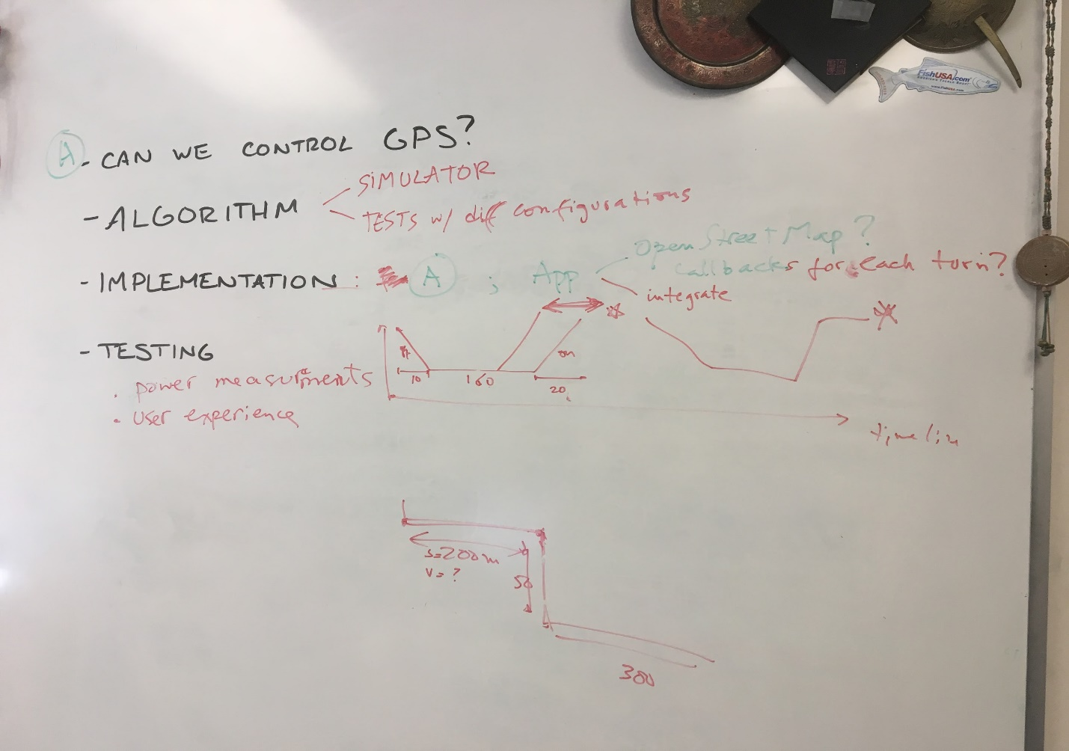 Overall, we believe this will be a very exciting and rewarding project to work on. There are clearly many roadblocks ahead and lots of uncertainties with how we will move forward with certain aspects of the project, but our result could be exceptionally useful if we are able to provide something of substance. We also look forward to working on the GPS lane navigation portion of the project if we get the time for it. Below we have included an image of the whiteboard Dr. Mossé and ourselves used to brainstorm when we met with him last week (you can see a breakdown of what we believe will be the biggest portions of the project we need to tackle, along with some diagrams showing how we might intend to control the GPS unit during the duration of a route).